Installation Guide

**Net-snmp Installation**

net-snmp is the snmp agent program for Linux. It must install to the Linux server before using the program.

Step 1.

Open the Terminal of the Linux server.

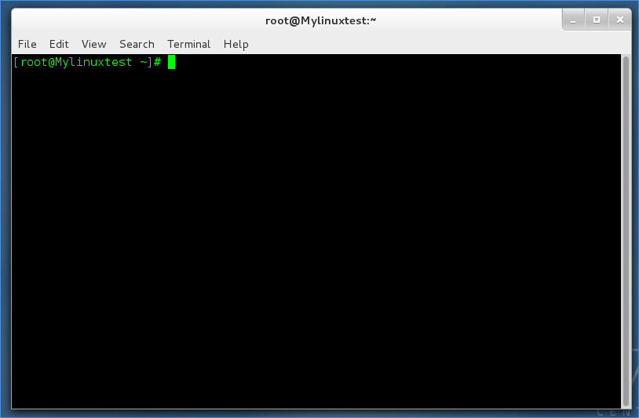

Step 2.

Type the command to install net-snmp as shown below

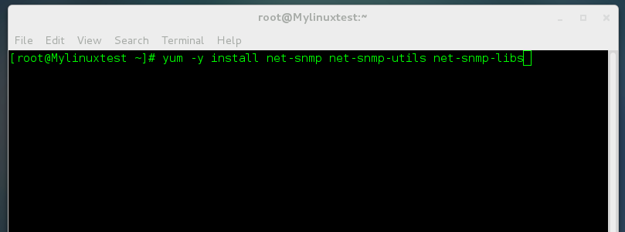

**Snmp Configuration**

Step 1.

Copy the configuration file name “snmpd.conf” attached in the zip file to target server directory /etc/snmp/ and replace it.

Step 2.

Configure the file depending on your needs.

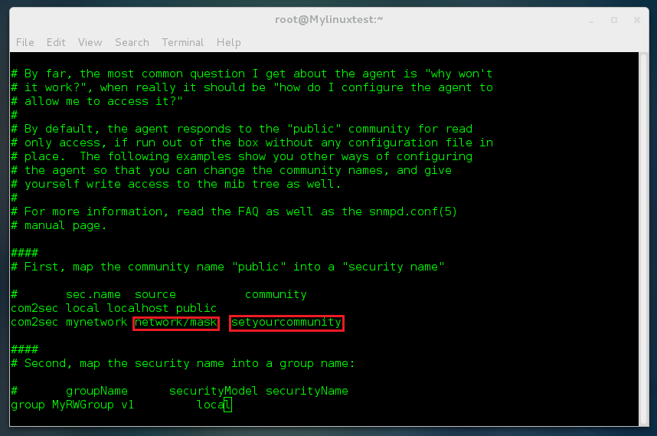

Set your community

Input your current network with mask

**Windows Snmp Configuration**

Step 1

Click “Start” -> “Control Panel” -> “Programs” -> “Turn Windows features on or off”

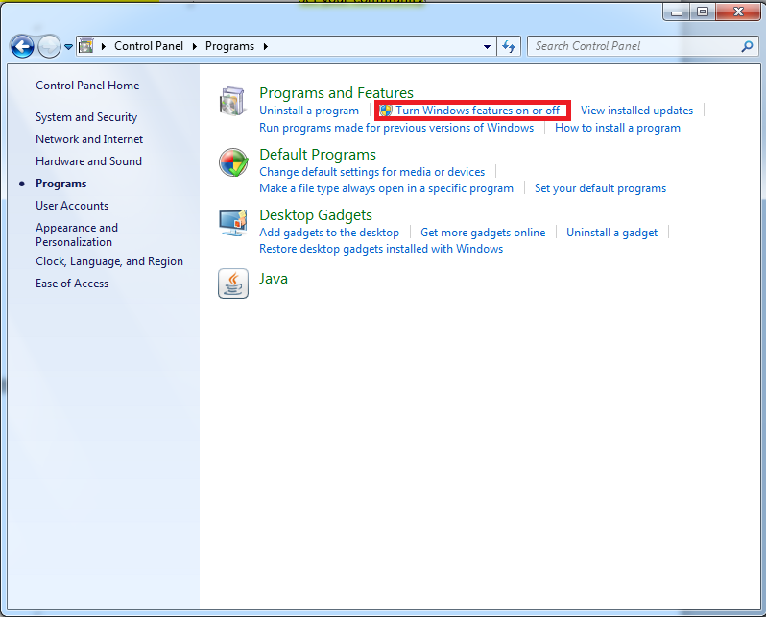

Step 2

Turn on the SNMP Service and click “OK”

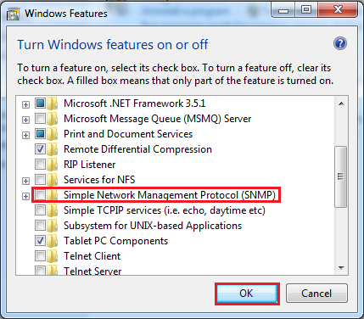

Step 3

Search “Services”

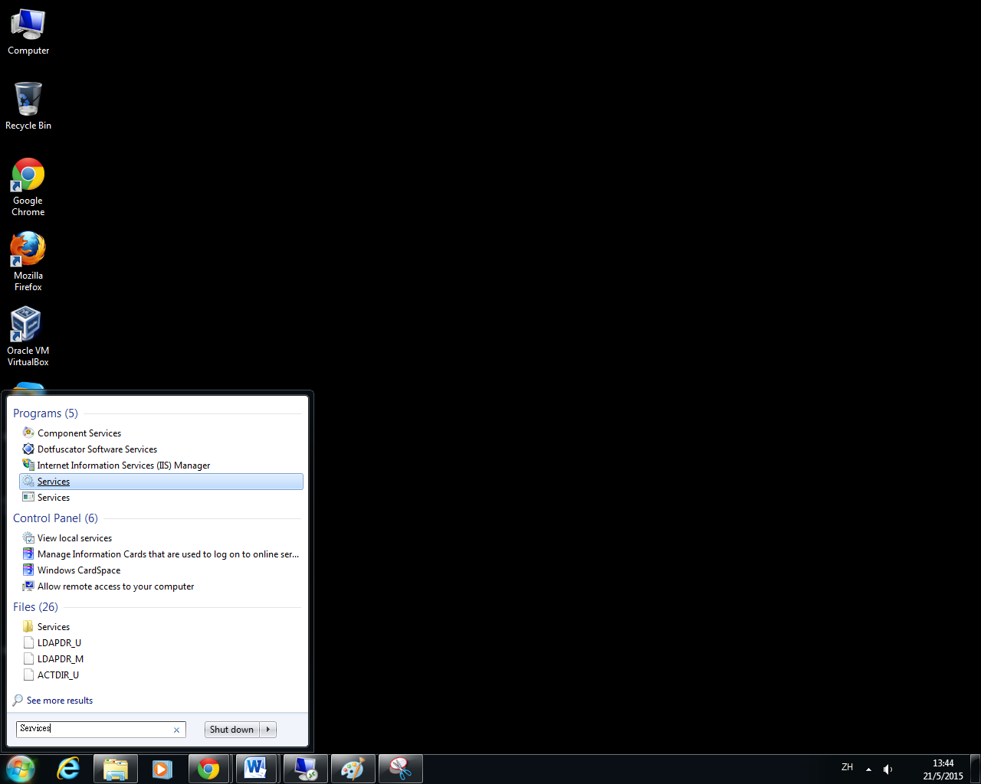

Step 4

Right click “SNMP Service” -> “Properties”

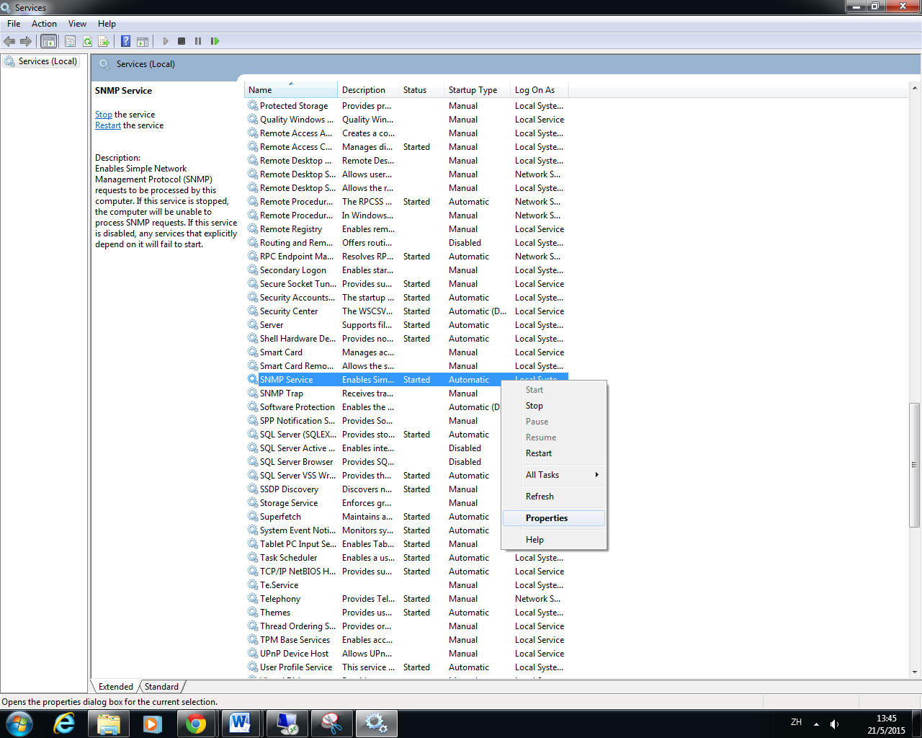

Step 5

Choose “Security” tab and click “Add”

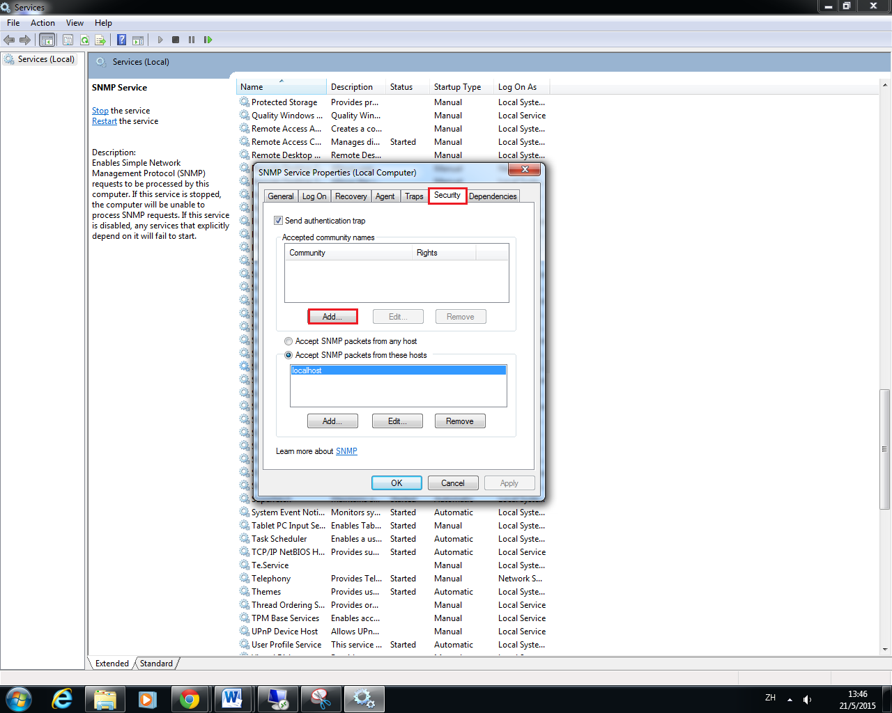

Step 6

Type your community here and click “OK”.

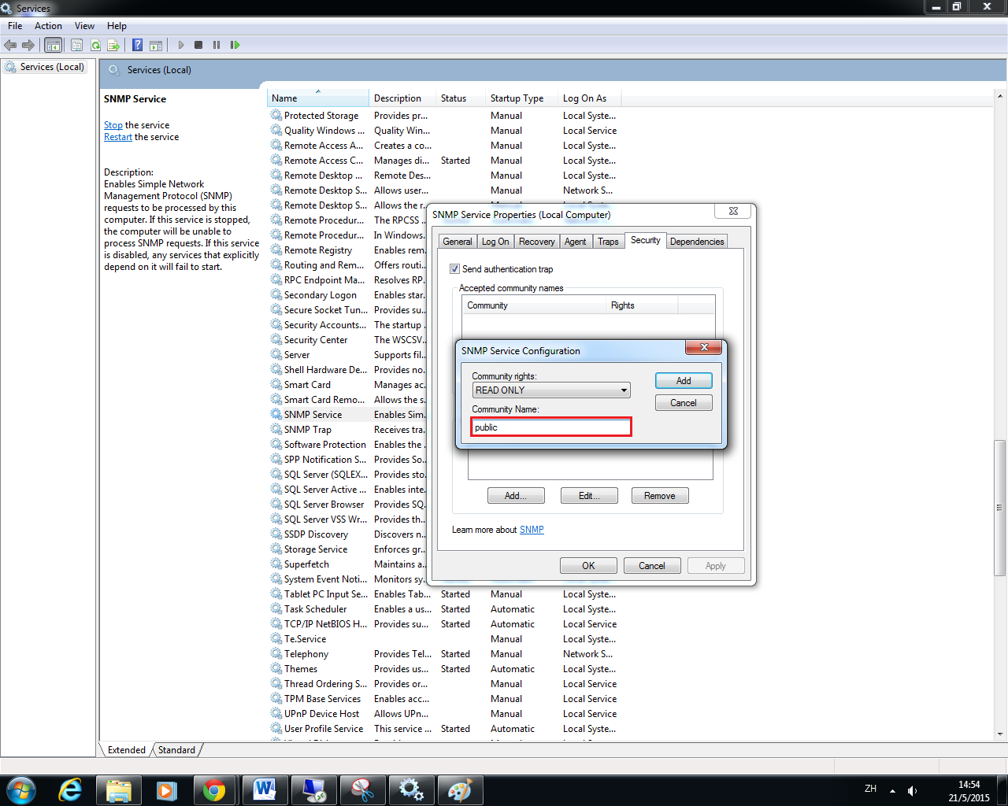

Step 7

You can choose “Accept SNMP packets from anyhost” or “Accept SNMP packets from thses hosts”. It is more secured.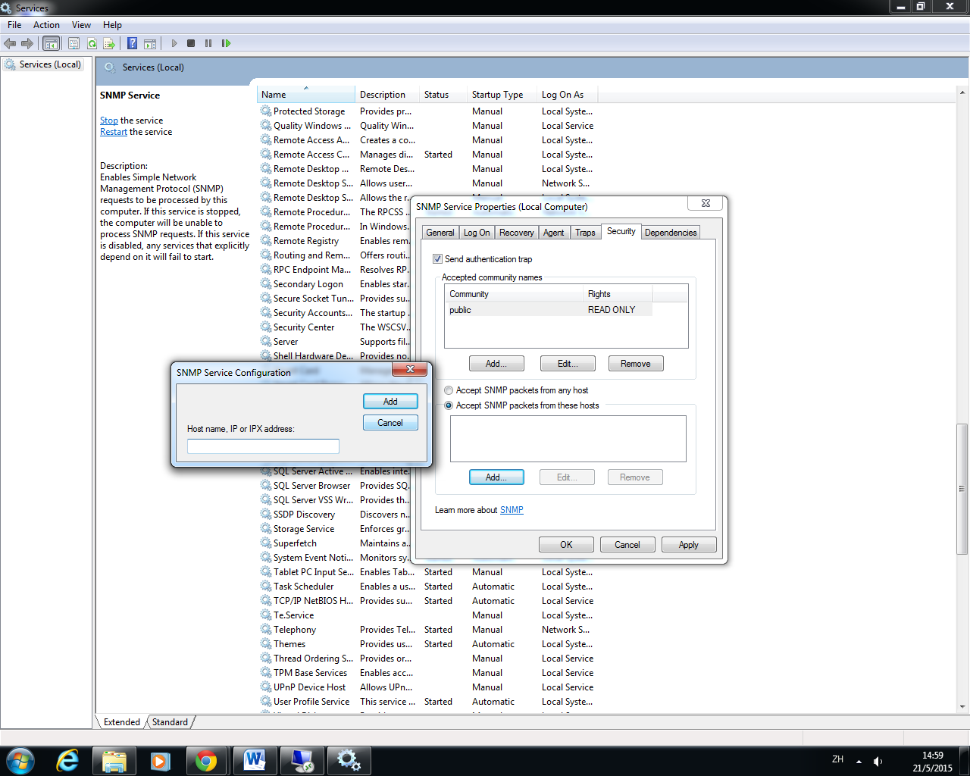

Step 8

Click “OK” to finish the configuration

**Cisco Router and Switch Configuration**

You can use the following command to configure the snmp service.

To check the snmp service

* show snmp

To configure the service

* snmp-server community public RO

#Words in red is the community

**MySQL Installation**

Step 1:

Go to <http://dev.mysql.com/downloads/mysql/> and download MySQL Community Server.

Step2: Open the MySQL installation file

Step3: Accept the lincense terms and press “Next”

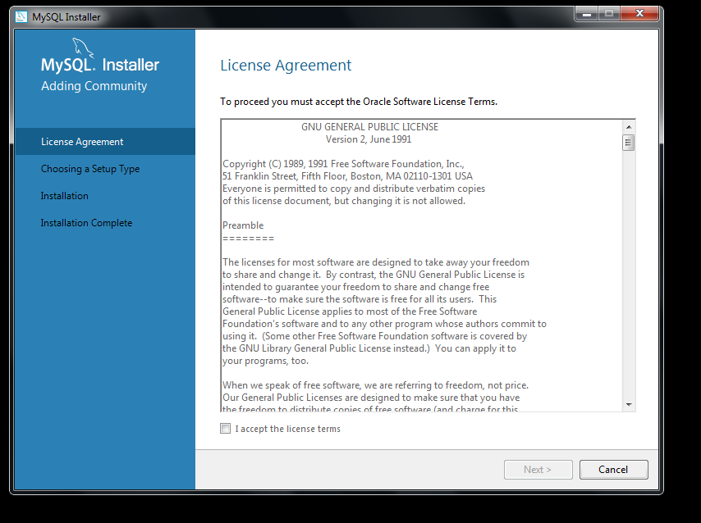

Step 4

Select Developer Deafult and press “Next”

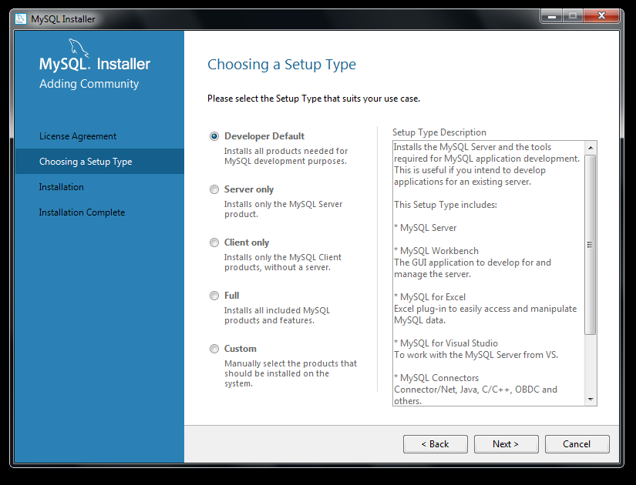

Step 5

Press “Next”

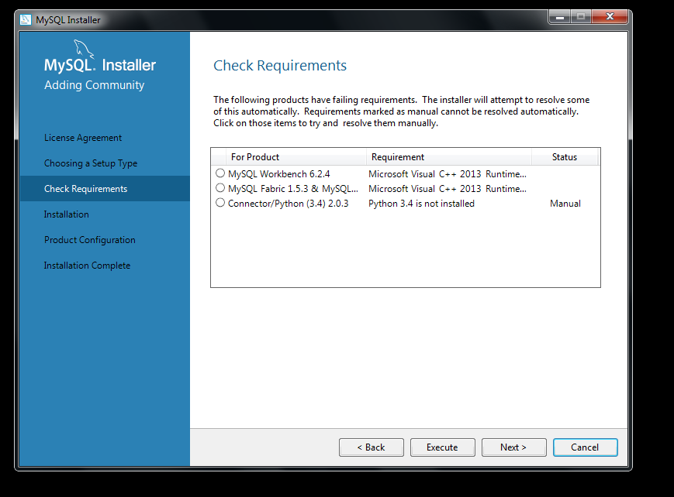

Step 6

Press “Execute”

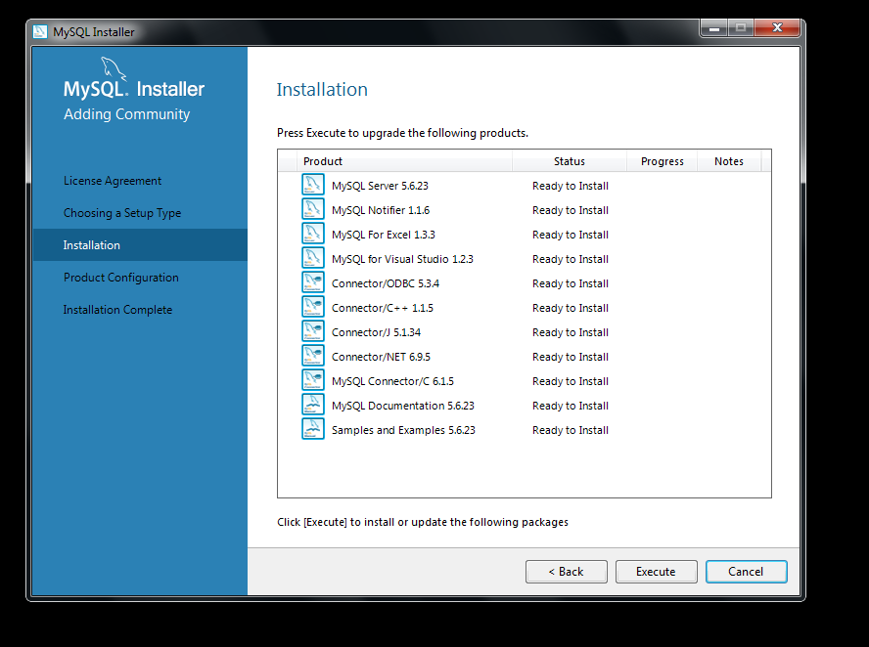

Step 7

Press “Next”

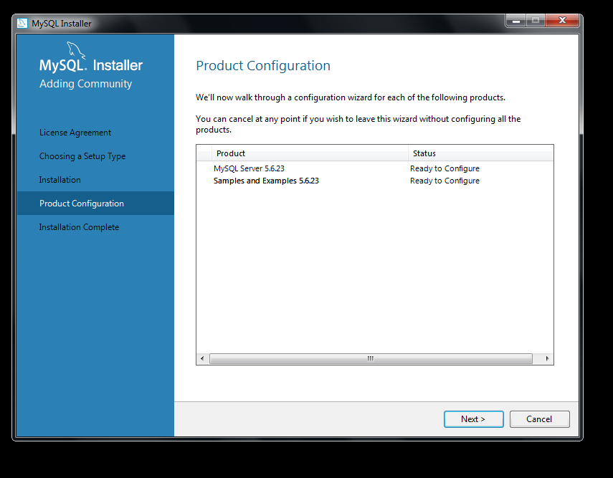

Step 8

Press “Next”

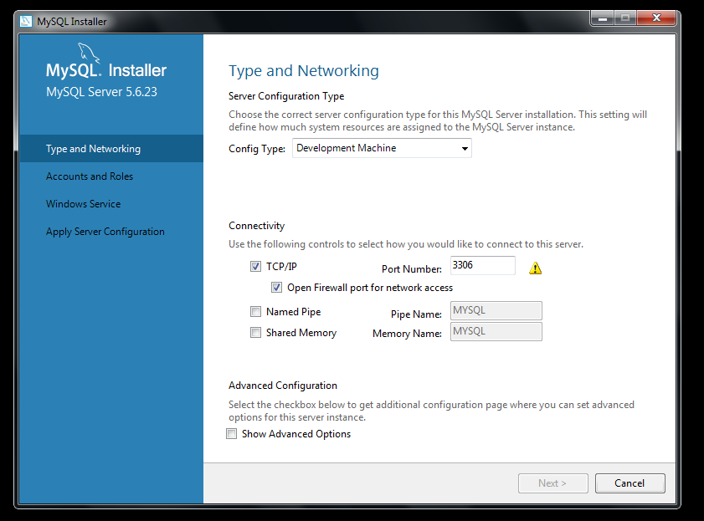

Step 7

Set up the root password and press “Next”

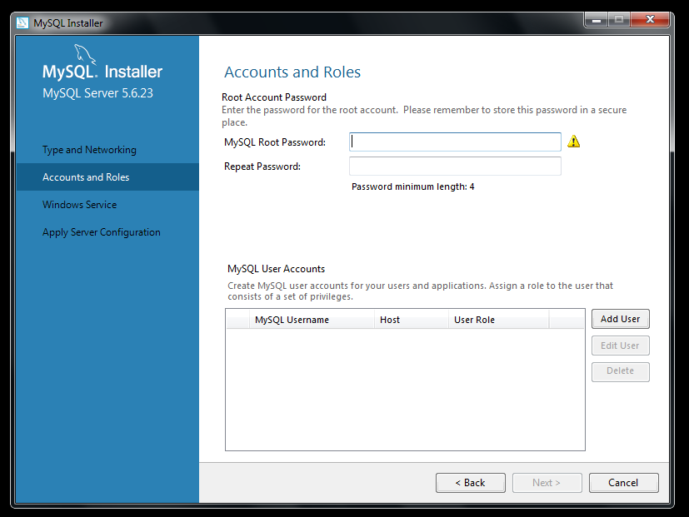

Step 8

Press “Next”

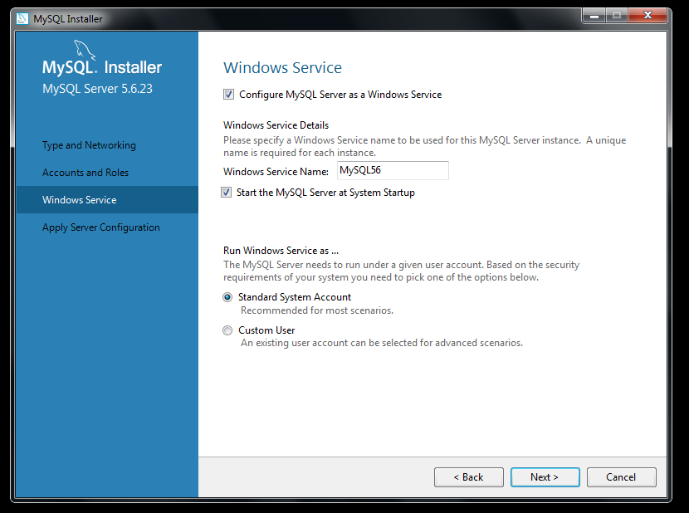

Step 9

Press “Execute”

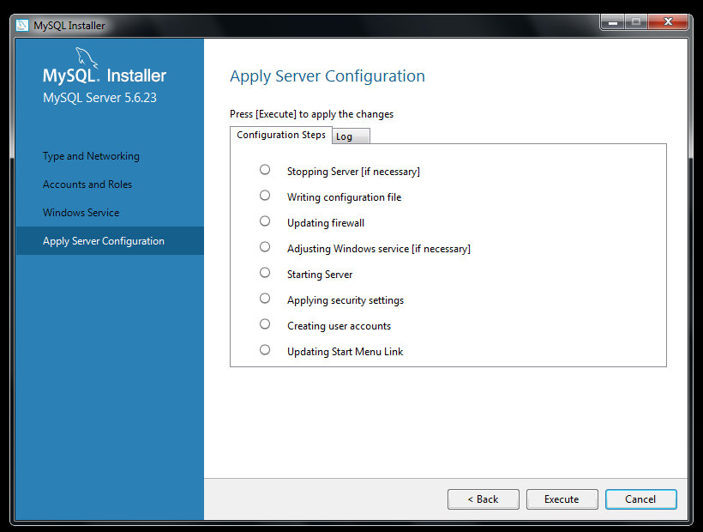

Step 10

Press “Next”

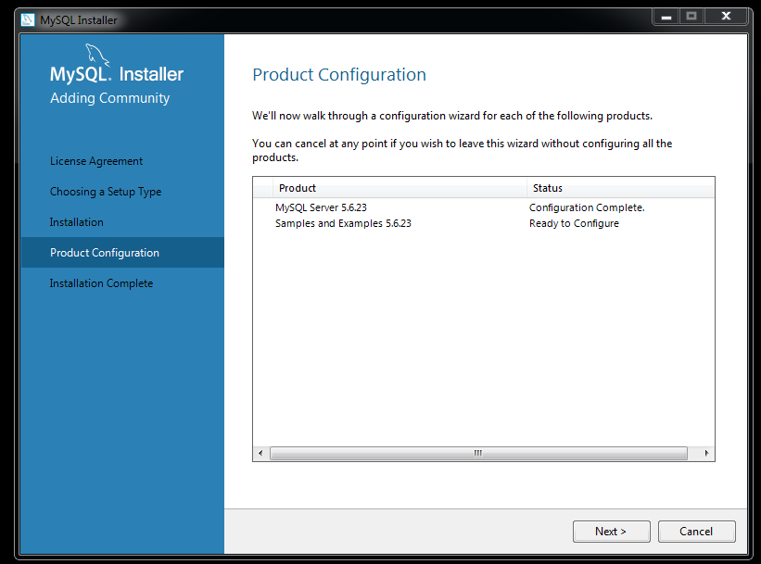

Step 11

Press “Check”

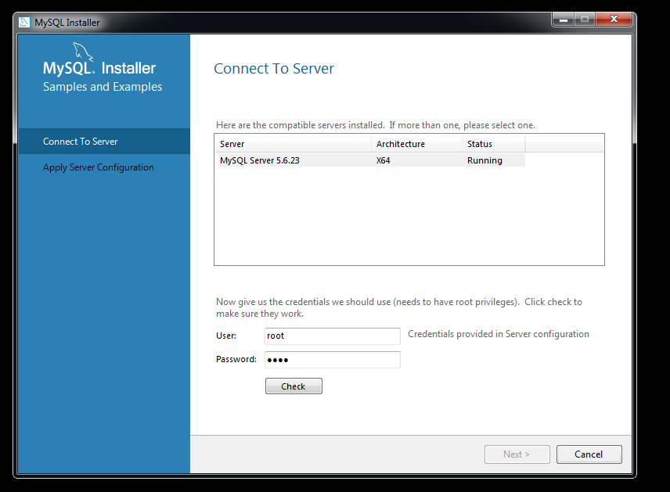

Step 12

Press “Next”

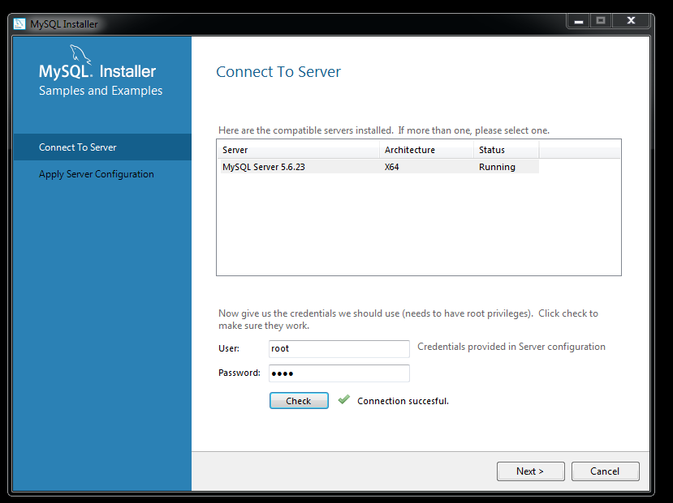

Step 13

Press “Execute”

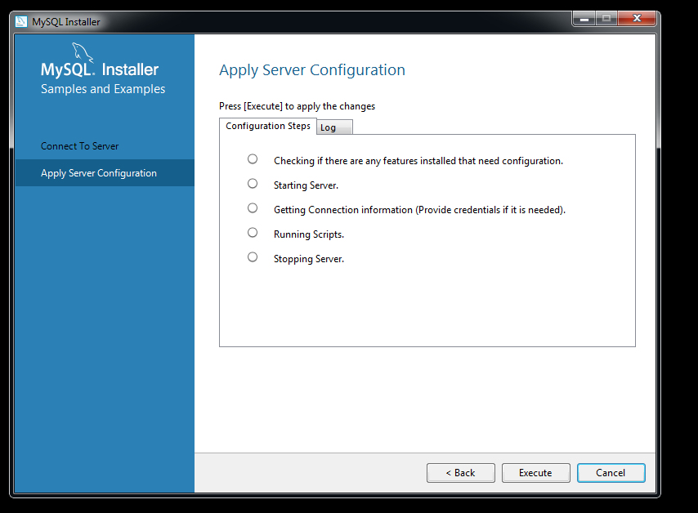

Step 14

Press “Next”

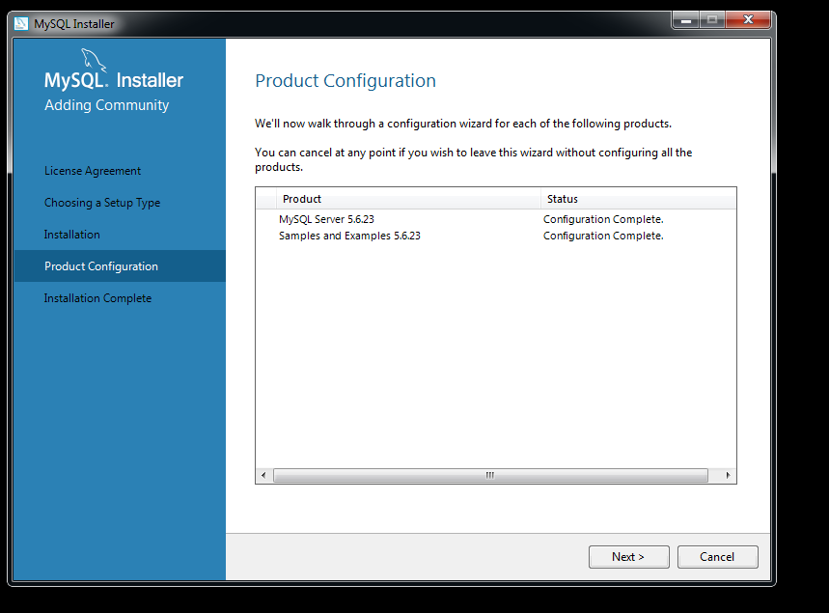

Step 15

Press “Finish”

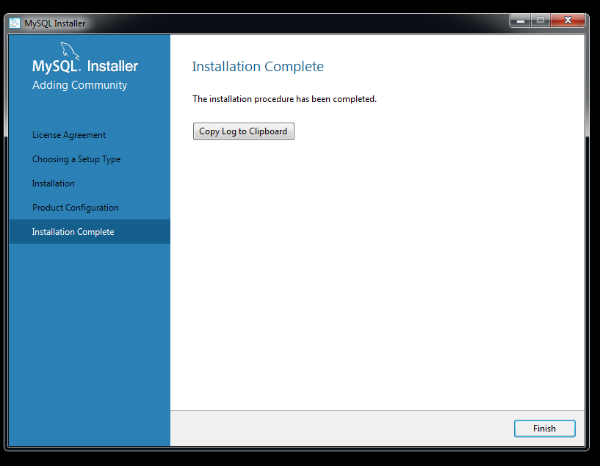

**MySQL has been installed.**